Enron Metals

Risk Management & Trade Accounting

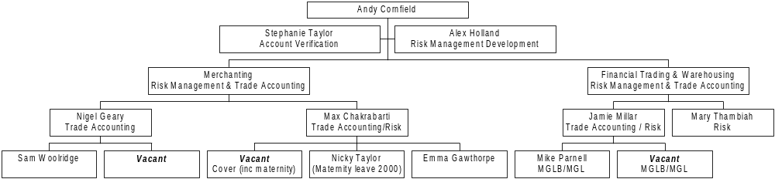

Notes:

- Nicky Taylor currently carries out extensive work relating to clean-up of data capture for the Agency business in New York. This needs to be staffed locally in New York to ensure correct entry first time.
- Depending upon how this reduces workload in the UK it may be necessary to acquire additional resource to cover Nicky Taylor’s maternity leave i.e. have a net additional resource.

